**City of Tacoma Regional Stormwater Facility Plan:** ATTACHMENT 2: Thea Foss Watershed

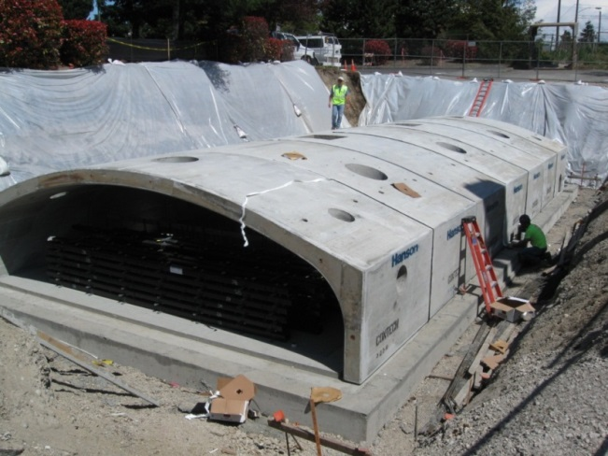Construction of Ferry Street Facility

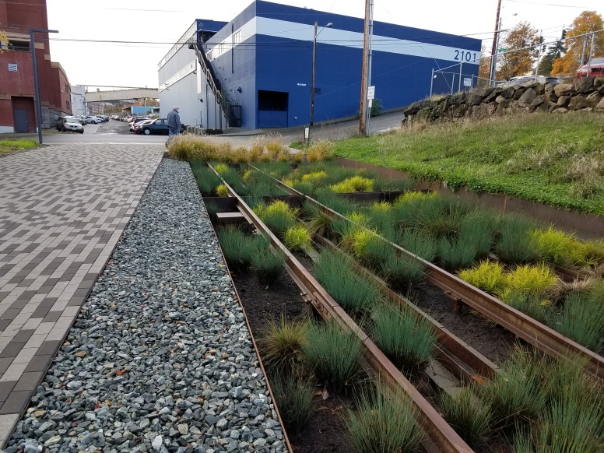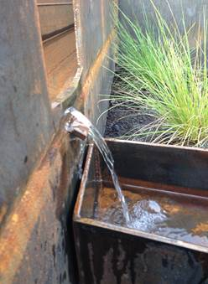

**UWT Regional Treatment Facility and Inlet Detail**

August 2022

Prepared by

City of Tacoma

Environmental Services Department

Science and Engineering Division, Environmental Programs Group



**Certification Language**

I hereby certify that this modeling report was prepared by me and that to my belief was prepared in accordance with the requirements of 18.43 RCW. I hereby certify that I am a licensed professional engineer under the laws of the State of Washington. This report is stamped and signed in accordance with Section 196-23-020(1) of the Washington Administrative Code and Section 18.43.070 of the Revised Code of Washington.



Table of Contents

Section 1 - Overview 1

Section 2 - Participation in the Payment In-Lieu-Of Construction Program 3

Section 3 - Foss Regional Stormwater Treatment Facilities 4

3.1.1 Ferry Street Facility Sizing and Mitigation Capacity Calculations 4

3.1.2 Ferry Street Life Cycle Costs and Mitigation Capacity Calculations 6

3.2 University of Washington Tacoma (UWT) Regional Treatment Facility 7

3.2.2 UWT Regional Treatment Facility Life Cycle Costs and Mitigation Capacity Calculations 10

3.2.3 UWT Regional Treatment Facility Stormwater Treatment and Maintenance Normalized Unit Costs 11

3.3 A Street Regional Facility 12

3.3.1 A Street Regional Treatment Facility Sizing and Mitigation Capacity Calculations 12

3.3.2 A Street Regional Treatment Life Cycle Costs and Mitigation Capacity Calculations 14

3.3.3 A Street Facility Stormwater Treatment and Maintenance Normalized Unit Costs 15

3.4 Total Stormwater Treatment Mitigation Capacity Available for In-Basin Transfer - Foss Watershed 16

List of Tables and Figures

Table 1-1 Program Costs and Capacity Credits Available

Table 3-1 Ferry Street – 61.42 Acre Contributing Basin

Table 3-2 Life Cycle Costs for Ferry Street Regional Facility

Table 3-3 Ferry Street Operation and Maintenance Costs

Table 3-4 UWT Regional Treatment Facility – 44.87 Acre Contributing Area

Table 3-5 Life Cycle Costs for UWT Regional Treatment Facility

Table 3-6 UWT Regional Treatment Facility Operation and Maintenance Costs

Table 3-7 A Street – 34.53 Acre Contributing Basin

Table 3-8 Life Cycle Costs for A Street Regional Treatment Facility

Table 3-9 A Street Facility Operation and Maintenance Costs

Table 3-10 Stormwater Treatment Mitigation Capacity Available

Figure 3-1 Ferry Street Basin Map

Figure 3-2 UWT Regional Treatment Facility Basin Map

Figure 3-3 A Street Regional Treatment Facility Basin Map

## Section 1 - Overview

The City built three Regional Stormwater Treatment Facilities in the Thea Foss Watershed: Ferry Street, A Street, and the University of Washington - Tacoma Regional Treatment Facility (UWT). The three facilities collectively are part of the City of Tacoma Payment In-Lieu-of Construction Program (Program). The Program allows the City to accelerate environmental improvements in the Thea Foss Watershed.

Qualifying new development and redevelopment projects within the Thea Foss Watershed will have the option of participating in the Payment In-Lieu-Of Construction Program by paying a one-time system development charge and an ongoing maintenance surcharge in-lieu-of providing individual site-specific stormwater treatment best management practices in order to meet Minimum Requirement (MR) #6 – Stormwater Treatment.

The system development charge is the aggregate present worth (PW) value for the capital costs (overall construction costs) of the three regional facilities converted to a normalized unit cost based on the aggregate of the pollution generating impervious surface area (PGIS) contributing to the regional facilities. The system development charge will be re-evaluated if changes to the stormwater system (including addition of new facilities) warrants re-evaluation and at least every ten years.

Because maintenance costs increased due to the construction of the three facilities, an ongoing maintenance surcharge will be applied. The ongoing maintenance surcharge is the annualized cost[1] converted to a normalized unit cost based on the aggregate of the pollution generating impervious surface area contributing to the regional facilities. The maintenance surcharge will be re-evaluated if maintenance requirements change and at least every ten years.

The maintenance surcharge will be assessed for only the onsite required stormwater mitigation for the project. Maintenance for offsite stormwater mitigation as part of this program is the responsibility of the City.

The system development charge and maintenance surcharge and available capacity to be included in the program is provided below in Table 1-1. Additional information about each facility and more in-depth calculations can be found later in this plan.

| **Table 1-1 – Program Costs and Capacity Credits Available** | |
| --- | --- |
| System Development Charge ($/square feet of required mitigated area) | $1.87 |
| Maintenance Surcharge ($/square feet of required mitigated onsite area) | $0.02 |
| Total Pollution Generating Impervious and Pollution Generating Pervious Areas Contributing to All Facilities (acres) | 99.98 |
| Total Pollution Generating Impervious Surfaces Contributing to All Facilities (acres) | 58.21 |
| Total Pollution Generating Pervious Surfaces Contributing to All Facilities (acres) | 41.76 |
| Portion of Total Pollution Generating Surfaces that Can be Used for Enhanced Treatment | 37.67 |
| Portion of Pollution Generating Impervious Surfaces that Can be Used for Enhanced Treatment (acres) | 17.73 |
| Portion of Pollution Generating Pervious Surfaces that Can be Used for Enhanced Treatment (acres) | 19.93 |

## Section 2 - Participation in the Payment In-Lieu-Of Construction Program

Tacoma Municipal Code 12.08D.260 establishes the Payment In-Lieu-Of Construction Program that allows for the payment of a system development charge in-lieu-of constructing stormwater treatment and/or flow control best management practices on the project site.

Qualifying new development and redevelopment projects located in the Thea Foss Watershed may pay a one-time system development charge and an ongoing maintenance surcharge (as necessary) in-lieu-of constructing individual site-specific stormwater treatment best management practices in order to meet Minimum Requirement #6 (MR #6). Public and private projects are eligible for participation in the program. This is a voluntary program.

Qualifying new and redevelopment projects:

* Must be approved for participation in the program by Environmental Services.
* Must meet all Minimum Requirements applicable to the project even if the program will be used to mitigate for MR #6. A Stormwater Site Plan must be submitted for review and approval – the project proponent must state that they are utilizing the program to meet the intent of MR#6.
* Cannot discharge into a wetland. Projects required to provide stormwater treatment in order to meet Minimum Requirement #8: Wetland Protection cannot participate in this program.
* Cannot also be requesting an Exception to a Minimum Requirement.
* Cannot be requesting to reserve capacity for potential future mitigation needs. The program only applies to the project submitted as part of the complete construction permit application.
* Must be associated with a construction permit not a land use permit.
* Cannot be a retroactive request for an already approved project.
* Must be approved to be in the program when there is 15% or greater capacity available in the regional facility (i.e., 85% capacity has not been utilized be preceding projects).
* Must complete a program application - the “Application for the City of Tacoma Payment In-Lieu-Of Construction Program – Foss Regional Stormwater Facility” and include this as part of a complete application for construction permits. Public projects proposing to utilize this program shall complete an application and submit it at the 60% design phase. The City of Tacoma Environmental Services will review this application as part of the construction permit review process. The applicant will be notified if the project is acceptable for inclusion in the Payment In-Lieu-Of Construction Program.
* Must be willing and able to enter into a Voluntary Agreement and Covenant with the City. The Voluntary Agreement and Covenant will be supplied by the City and shall be recorded to title of the associated parcel(s) of land.
* Must be willing and able to pay all associated fees including costs to record any documents with the Pierce County Assessor.
* Must have similar pollution characteristics as the areas contributing to the regional facility.
* Cannot require a treatment type that the regional facility does not provide. For example, projects that require oil or phosphorus treatment must provide individual onsite oil or phosphorous treatment BMPs.
  + All regional facilities in this program provide basic treatment.
  + The UWT facility provides enhanced treatment.
* Must have a discharge location into the receiving waterbody that is the same discharge location as or is upstream of the discharge location of the regional facilities.

## Section 3 - Foss Regional Stormwater Treatment Facilities

The Thea Foss Regional Stormwater Treatment Facilities are located within the Thea Foss Watershed. Stormwater is conveyed through the watershed primarily by underground conveyance systems and some above-ground ditch systems.

Additional information about the Thea Foss Watershed can be found at: https://www.cityoftacoma.org/watershed_planning.

The City currently has three regional stormwater treatment facilities located in the Foss Watershed that collectively make up the Thea Foss Regional Stormwater Treatment Facilities. Payment In-Lieu-of Construction Program. This section describes each facility, its sizing and costs, and the mitigation capacity.

### 3.1.1 Ferry Street Facility Sizing and Mitigation Capacity Calculations

The vault was designed for a 50-acre site (41 acres impervious and 9 acres pervious). During facility construction, additional area was also routed to the flow splitter to increase the actual contributing area to 61.42 acres.

A 72-inch Weir Type flow splitter structure was sized to transfer the Western Washington Hydrology Model (WWHM) off-line water quality flowrate of 3.76 cubic feet per second (cfs) to the vault. Any flows greater than this amount discharge directly to the downstream stormwater system and bypass the facility.

The ZPG StormFilter cartridges are approved by Ecology as General Use Level Designation for Basic (TSS) Treatment at a design flowrate of 7.5 gallons per minute (gpm). The 226 cartridge StormFilter vault is oversized for the 3.76 cfs for which it was designed – only 225 cartridges are required at that flowrate.

**Figure 3-1**: Ferry Street Basin – Impervious and Pervious Surfaces provides an overview of the amount of pollution generating impervious surface, pollution generating pervious surface, and non-pollution generating pervious surface contributing to the Ferry Street Facility. Table 3-1: Ferry Street – 61.42 Acre Contributing Basin also shows these values.

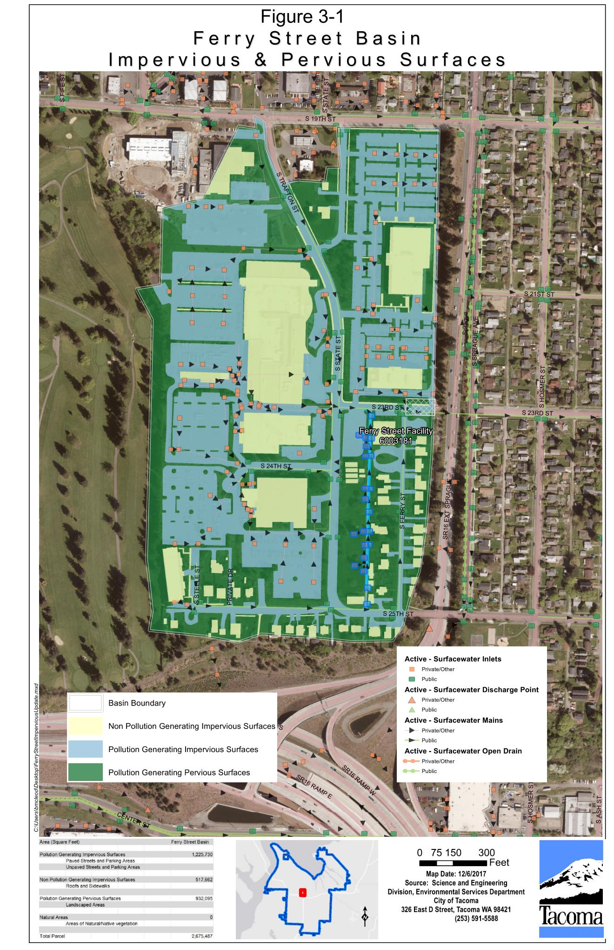The area of the PGIS, NPGIS, and PGPS were estimated using aerial photos and GIS mapping information as follows.

* Pollution Generating Impervious Surfaces (PGIS) includes roads, driveways, and parking areas.
* Non-Pollution Generating Impervious Surfaces (NPGIS) includes roofs and sidewalks.
* Pollution Generating Pervious Surfaces (PGPS) that includes landscaped areas.

|  |  |  |
| --- | --- | --- |
| **Table 3-1: Ferry Street - 61.42 Acre Contributing Basin** | | |
| Surface Type | Area (ft2) | Area (acres) |
| Total Area | 2,675,487 | 61.42 |
| Pollution Generating Impervious Surface | 1,225,730 | 28.14 |
| Pollution Generating Pervious Surface | 932,095 | 21.40 |
| Non-Pollution Generating Impervious Surface | 517,662 | 11.88 |

The amount available to participate in this program is limited to the amount of pollution generating surfaces that contribute to the facility and the facility design.

The offline water quality flowrate from the 61.42 acre contributing basin is 3.45 cfs as calculated using WWHM. Because this value is less than the value used in the original design (50-acre basin), the entirety of the basin’s pollution generating surface can be used in the program.

### 3.1.2 Ferry Street Life Cycle Costs and Mitigation Capacity Calculations

Total capital costs for the Ferry Street Facility were $921,187. The capital costs are based on actual contract and project costs for construction of the Ferry Street Facility. The maintenance cycle includes an annual inspection and once every 3 years filter replacement. O&M costs are based on actual O&M costs incurred by the City of Tacoma for the Ferry Street Facility. Capitalized annual costs (the Present Worth of a project with an infinite life) and life cycle costs for 20 years are provided in Table 3-2.

|  |  |
| --- | --- |
| **Table 3-2: Life Cycle Costs for Ferry Street Regional Facility** | |
| Capital Cost[2] | $921,187 |
| Total EUAC[3] | $13,387 |
| Capitalized Annual Costs[4] | $1,259,425 |
| Present Worth, Operation and Maintenance Costs[5] | $151,012 |
| Capital Recovery, Operation and Maintenance Costs[6] | $11,115 |

**3.1.3 Ferry Street Facility Stormwater Treatment and Maintenance Normalized Unit Costs**

The stormwater treatment normalized unit cost ($ per square feet) for the Ferry Street Regional Facility is the Capital Cost divided by the pollution generating impervious surface draining to the facility:

$921,187 ÷1,225,730 square feet=$0.75 per square foot

The maintenance normalized unit cost is the annualized cost based upon the Capital Recovery value for the O&M activities over a twenty-year life of the regional facility:

$11,114.51 ÷1,225,730 square feet=$0.01 per square foot

See Table 3-3 below which shows the Operation and Maintenance Costs used to determine the maintenance normalized unit cost. These costs are based upon time and cost estimates from 2015 maintenance records.

|  |  |  |  |  |  |
| --- | --- | --- | --- | --- | --- |
| **Table 3-3 – Ferry Street Operation and Maintenance Costs** | | | | | |
| Item | Description | Quantity | Units | Unit Cost | Subtotal |
| Annual Inspection | | | | | |
| Inspection |  | 1.5 | Hours | $95 | $143 |
|  |  |  |  | Total Annual Cost | $143 |
| 3 Year Maintenance Cost | | | | | |
| Filter Replacement | Filter Cost and Freight | 266 | Canister | $76 | $20,216 |
| Vactor | Vactor and Labor | 140 | Hours | $116 | $16,278 |
| Material Disposal |  | 7 | Tons | $38 | $266 |
| Total 3-Year Maintenance Cost | | | | | $36,760 |
| 3-Year Equivalent Uniform Annual (EUAC) Cost | | | | | $13,244.56 |
| Total EUAC | | | | | $13,387 |

Construction of this facility increased the City’s maintenance costs and a maintenance surcharge will be applied to Program participants. The Ferry Street Facility stormwater treatment and maintenance normalized unit cost will be included when determining the overall program costs (see Section 4).

## 3.2 University of Washington Tacoma (UWT) Regional Treatment Facility

The total contributing basin to the UWT Regional Treatment Facility is 44.87 acres of the Thea Foss Watershed in Asset Management area, FS06. The UWT Regional Treatment Facility is located along the Prairie Line Trail (formerly Hood Street Corridor) adjacent to South 21st Street (between Jefferson Avenue and C Street) on the University of Washington – Tacoma Campus. The facility is a Contech CDS pretreatment system followed by six bioretention cells utilizing filterra media, ranging from 535 to 545 square feet in size, with underdrains. The pretreatment device removes trash, debris, and large solids. After pretreatment, stormwater enters two distribution manholes that evenly distribute stormwater to each of the six bioretention cells. Flows from the distribution manholes flow to open steel channels and distribution trenches that overflow and disperse stormwater as sheet flow onto the media.

**3.2.1 UWT Regional Treatment Facility Sizing and Mitigation Capacity Calculations**

The treatment system was originally designed for a 42-acre site (35.7 acres impervious and 6.3 acres pervious) for full build out conditions of 85% impervious and 15% pervious. A flow splitter structure was sized to transfer the water quality design flowrate of 3.52 cfs to the downstream facilities that consist of a Contech CDS pretreatment device and 6 bioretention cells. Any flows greater than this amount discharge directly to the downstream system and bypass the facility.

The filterra media is approved by the Washington State Department of Ecology (Ecology) for basic and enhanced treatment. The original design flowrate approved by Ecology was 24.82 inches/hour. The design flowrate approved by Ecology is now 175 in/hour for both basic and enhanced treatment.

Changes to the City of Tacoma stormwater system will route 44.87 acres to the treatment system. Additional analysis was completed which show that the treatment system can still accommodate the additional flows being routed to the system. The General Use Level Designation for filterra media allows for a much high flowrate 175 in/hour versus 24.82 in/hr from the original design that will clearly accommodate the minor increase in contributing area (2.87 acres or 7% increase).

An additional flow splitter structure was sized to transfer the Western Washington Hydrology Model (WWHM) off-line water quality flowrate of 3.61 cfs to the downstream treatment system.

Figure 3-2: UWT Regional Treatment Facility Basin Map provides an overview of the amount of pollution generating impervious surface, pollution generating pervious surface, and non-pollution generating surface contributing to the UWT Regional Treatment Facility. Table 3-4: UWT Regional Treatment Facility – 44.87 Acre Contributing Basin also shows these values.

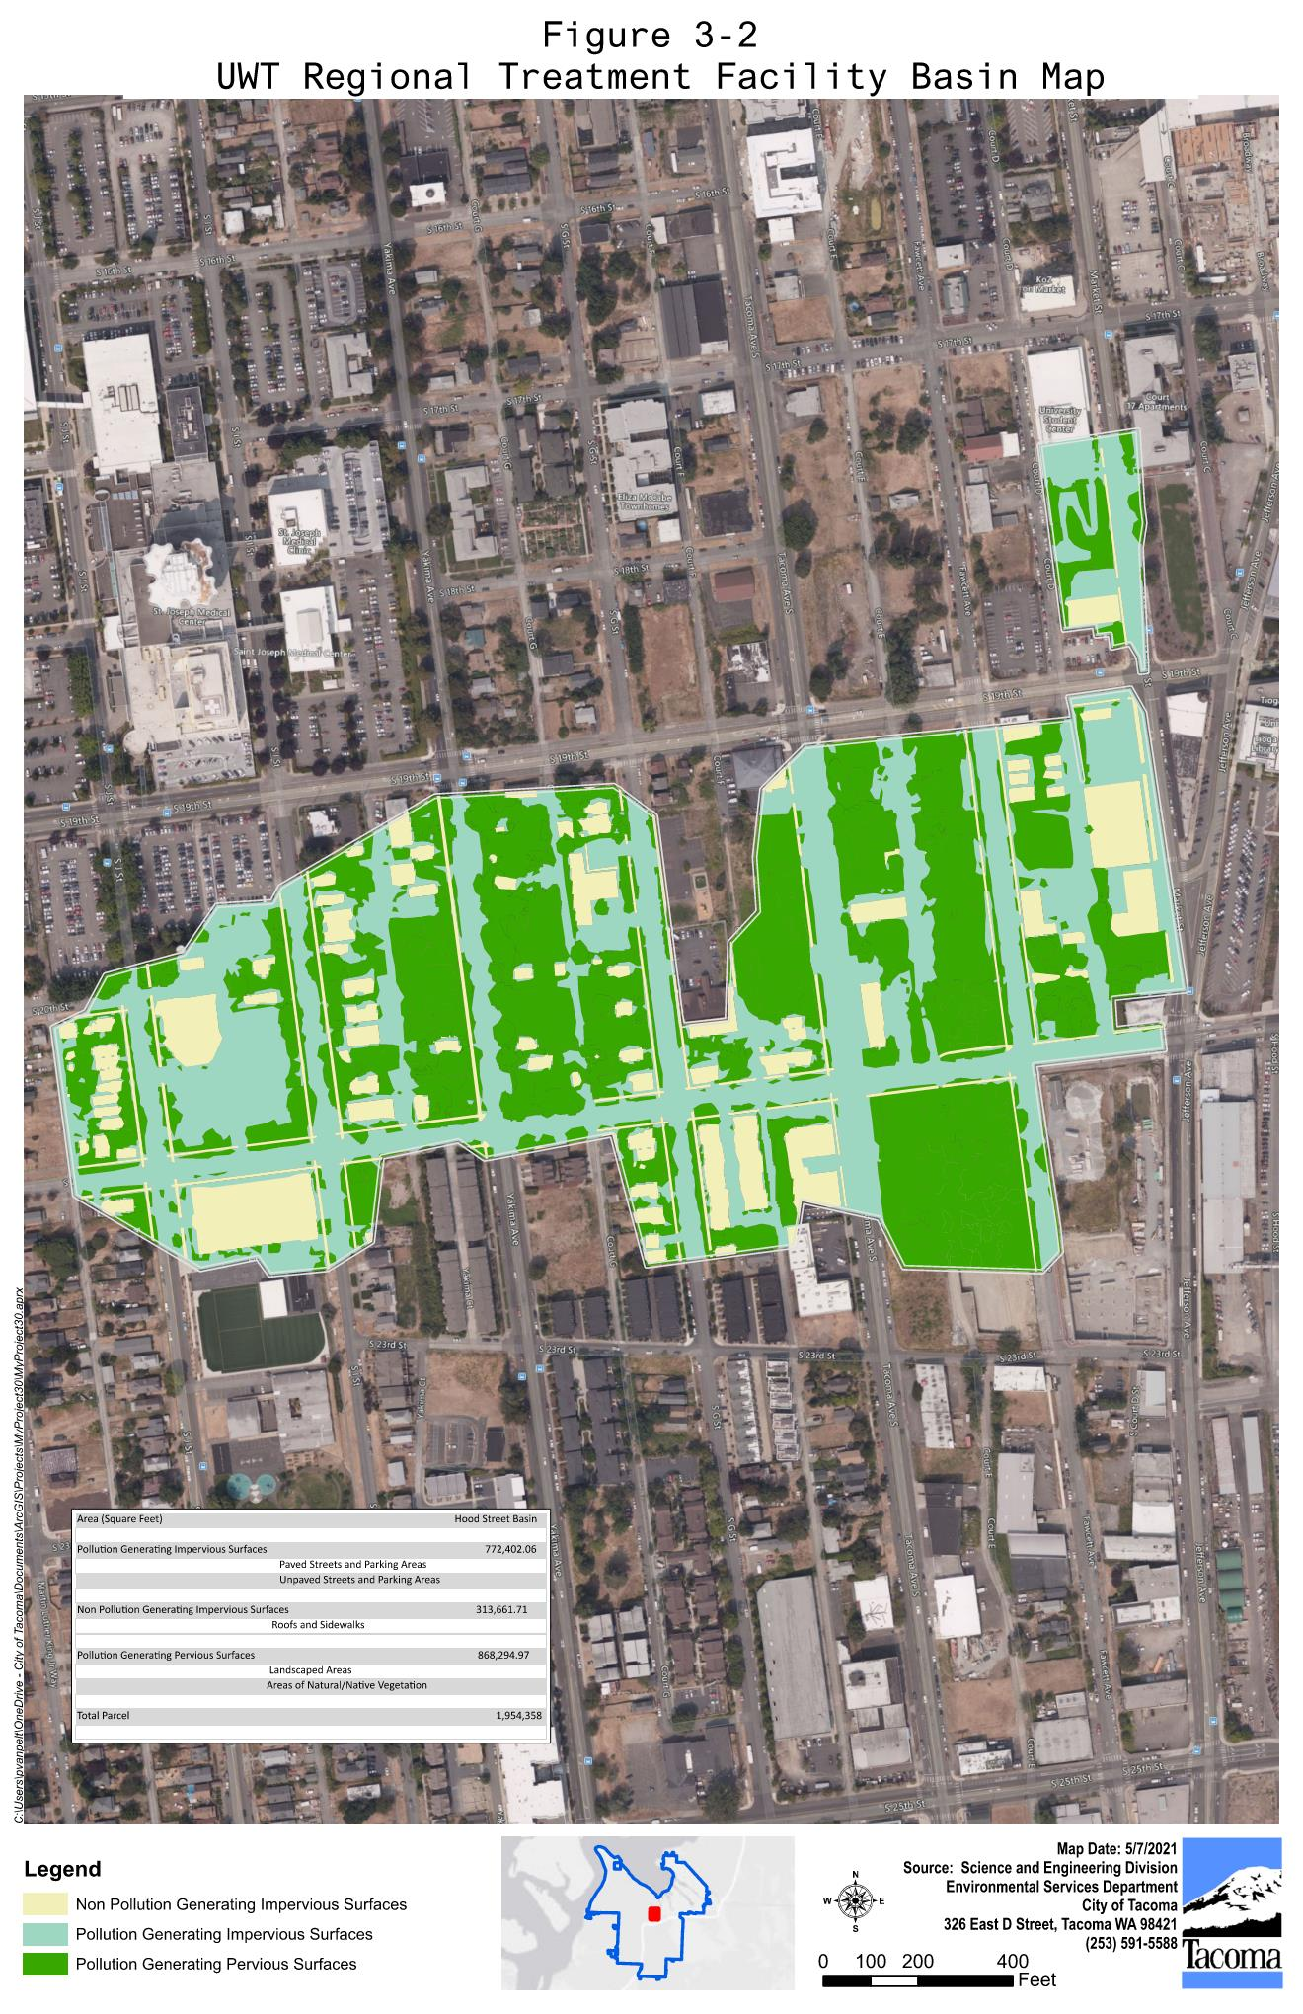

The area of the PGIS, NPGIS, and PGPS were estimated using aerial photos and GIS mapping information as follows.

* Pollution Generating Impervious Surfaces (PGIS) includes roads, driveways, and parking areas.
* Non-Pollution Generating Impervious Surfaces (NPGIS) includes roofs and sidewalks.
* Pollution Generating Pervious Surfaces (PGPS) that includes landscaped areas.

|  |  |  |
| --- | --- | --- |
| **Table 3-4: UWT Regional Treatment Facility - 44.87 Acre Contributing Basin** | | |
| Surface Type | Area (ft2) | Area (acres) |
| Total Area | 1,954,359 | 44.87 |
| Pollution Generating Impervious Surface | 772,402 | 17.73 |
| Pollution Generating Pervious Surface | 868,295 | 19.93 |
| Non-Pollution Generating Impervious Surface | 313,662 | 7.2 |

The amount available to participate in this program is limited to the amount of pollution generating surfaces that contribute to the facility and to the facility design.

### 3.2.2 UWT Regional Treatment Facility Life Cycle Costs and Mitigation Capacity Calculations

Total capital costs for the UWT Regional Treatment Facility were $2,357,018. The capital costs are based on actual contract and project costs for construction of the UWT Regional Treatment Facility. The maintenance cycle includes annual maintenance with a 20-year media/plant replacement. Operation and Maintenance (O&M) costs are based on actual O&M costs incurred by the City of Tacoma for the UWT Regional Treatment Facility. Capitalized annual costs (the present worth of a project with an infinite life) and life cycle costs for 20 years are provided in Table 3-5.

|  |  |
| --- | --- |
| **Table 3-5: Life Cycle Costs for UWT Regional Treatment Facility** | |
| Capital Cost[7] | $2,357,018 |
| Total EUAC[8] | $30,778 |
| Capitalized Annual Costs[9] | $3,126,468 |
| Present Worth, Operation and Maintenance Costs[10] | $317,950 |
| Capital Recovery, Operation and Maintenance Costs[11] | $23,401 |

### 3.2.3 UWT Regional Treatment Facility Stormwater Treatment and Maintenance Normalized Unit Costs

The stormwater treatment normalized unit cost ($ per square feet) for the UWT Regional Treatment Facility is the capital cost divided by the pollution generating impervious surface draining to the facility:

$$\$2,357,018.00 ÷772,402square feet =\$3.05 per square foot$$

The maintenance normalized unit cost is based upon life cycle costs. The maintenance normalized unit cost is the annualized cost based upon the Capital Recovery value for the O&M activities over a twenty-year life of the regional facility:

$$\$23,401.11 ÷772,402 square feet =\$0.03 per square foot$$

See Table 3-6 below which shows the Operation and Maintenance Costs used to determine the maintenance normalized unit cost. These costs are based on time and cost estimates from 2 years of maintenance data taken from 2015-2017.

|  |  |  |  |  |  |
| --- | --- | --- | --- | --- | --- |
| **Table 3-6 – UWT Regional Facility Operation and Maintenance Costs** | | | | | |
| Item | Description | Quantity | Units | Unit Cost | Subtotal |
| Annual Costs | | | | | |
| Inspection |  | 1.5 | Hours | $100 | $150 |
| CDS Flow Splitter Maintenance | Vactor Manhole – 2 Times Per Year | 5 | Hours | $264 | $1,318 |
| Brush Work | Vegetation Maintenance – 6 Times Per Year | 18 | Hours | $309 | $5,565 |
| Mulch Rejuvenation | Maintain 3” Mulch Layer | 30 | Cubic Yards | $41 | $1,226 |
| Mulch Rejuvenation | Crew Hours | 24 | Hours | $309 | $7,421 |
| Material Disposal |  | 40 | Tons | $38 | $1,520 |
| Total Annual Cost | | | | | $17,200 |
| 20 Year Maintenance Cost Estimate | | | | | |
| Plantings | Replace Plants | 3525 | Square Foot | $9 | $31,725 |
| Mulch | Remove and Replace 3” Mulch | 30 | Cubic Yards | $41 | $1,226 |
| Media | Full Media Replacement | 581,400 | Pounds | $0.24 | $138,955 |
| Disposal |  | 331 | Ton | $38 | $12,581 |
| Total 20-Year | | | | | $184,487 |
| 20-Year Equivalent Uniform Annual (EUAC) Cost | | | | | $13,578 |
| Total EUAC | | | | | $30,778 |

Construction of this facility increased the city’s maintenance costs and a maintenance surcharge will be applied in the Foss Watershed. The UWT Regional Treatment Facility stormwater treatment and maintenance normalized unit cost will be included in the development of the aggregate for the Foss Watershed (see Section 3.4).

## 3.3 A Street Regional Facility

The total contributing basin to the A Street Regional Facilities is 34.53 acres of the Thea Foss Watershed in Asset Management area, FS05. The A Street Regional Facility is two vaults, one on 10th Street and one on 11th Street, both near the A Street intersections. Each vault treats a branch of the A Street stormwater conveyance system.

The 10th Street Vault is 8 feet by 20 feet with 16 EMC 30” BayFilter® cartridges. The 11th Street Vault is 8 feet by 23 feet with 23 EMC 30” BayFilter® cartridges.

### 3.3.1 A Street Regional Treatment Facility Sizing and Mitigation Capacity Calculations

The vaults were designed for a 33.32 acre contributing basin. The 10th Street Vault is an in-line system and was sized to transfer the WWHM on-line water quality flowrate of 1.52 cfs through the vault. For the 11th Street Vault, a 60-inch Weir Type flow splitter structure was sized to transfer the WWHM off-line water quality flowrate of 2.26 cfs to the vault. Any flows greater than this amount discharge directly to the stormwater system and bypass the vaults.

The EMC BayFilter® cartridges are approved by the Washington State Department of Ecology as General Use Level Designation for Basic (TSS) Treatment at a flowrate of 45 gpm.

The actual contributing area increased to 34.53 acres (due to changes of stormwater pipes and catch basin locations). The BayFilter units can accommodate the additional acreage draining to each facility.

Figure 3-3: A Street Regional Treatment Facility Basin Map provides an overview of the amount of pollution generating impervious surface, pollution generating pervious surfaces, and non-pollution generating pervious surfaces contributing to the A Street Facility. Table 3-7 – A Street – 34.53 Acre Contributing Basin also shows these values.

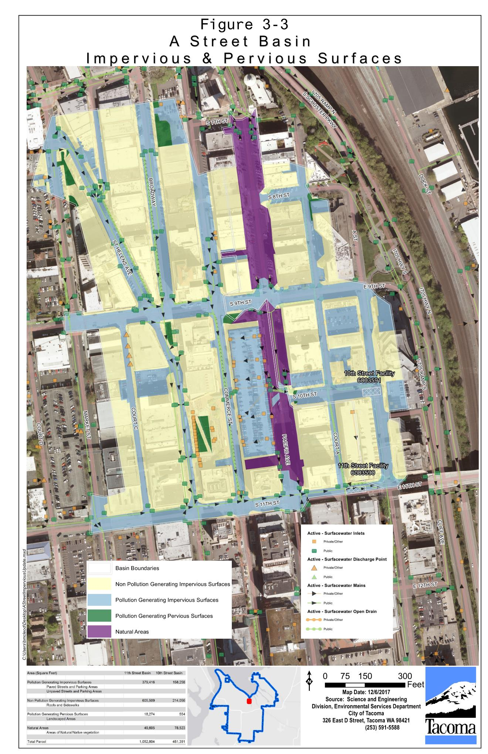

The area of the PGIS, NPGIS, and PGPS were estimated using aerial photos and GIS mapping information as follows.

* Pollution Generating Impervious Surfaces (PGIS) includes roads, driveways, and parking areas.
* Non-Pollution Generating Impervious Surfaces (NPGIS) includes roofs and sidewalks.
* Pollution Generating Pervious Surfaces (PGPS) includes landscaped areas.
* Natural Areas includes areas of natural/native vegetation and is limited to the areas that contribute stormwater to the Pacific Avenue Bioretention Facilities.

|  |  |  |  |  |  |  |
| --- | --- | --- | --- | --- | --- | --- |
| **Table 3-7: 34.53 Acre Contributing Basin** | | | | | | |
| Surface Type | Total Area (ft2) | Total Area (acres) | 11th Street Basin (ft2) | 11th Street Basin (acres) | 10th Street Basin (ft2) | 10th Street Basin (acres) |
| Total Area | 1,504,195 | 34.53 | 1,052,804 | 24.17 | 451,391 | 10.36 |
| Pollution Generating Impervious Surface | 537,674 | 12.34 | 379,416 | 8.71 | 158,258 | 3.63 |
| Pollution Generating Pervious Surface | 18,828 | 0.43 | 18,274 | 0.42 | 554 | 0.01 |
| Non-Pollution Generating Impervious Surface | 819,565 | 18.82 | 605,509 | 13.90 | 214,056 | 4.91 |
| Natural Areas | 128,128 | 2.94 | 49,605 | 1.14 | 78,523 | 1.80 |

The amount available to participate in this program is limited to the amount of pollution generating surfaces that contribute to the facility and to the facility design.

### 3.3.2 A Street Regional Treatment Life Cycle Costs and Mitigation Capacity Calculations

Total capital costs for the A Street Facility was $1,548,427. The capital costs are based on actual contract and project costs for construction of the A Street Facilities. The maintenance cycle is an annual inspection and once every two years, filter replacement. O&M costs are based on actual O&M costs incurred by the City of Tacoma for similar media filtration vault facilities. Capitalized annual costs (the PW of a project with an infinite life) and life cycle costs for 20 years are provided in Table 3-8.

|  |  |
| --- | --- |
| **Table 3-8: Life Cycle Costs for A Street Regional Facility** | |
| Capital Cost[12] | $1,548,427 |
| Total EUAC[13] | $6,599 |
| Capitalized Annual Costs[14] | $1,713,403 |
| Present Worth, Operation and Maintenance Costs[15] | $83,122 |
| Capital Recovery, Operation and Maintenance Costs[16] | $6,117 |

### 3.3.3 A Street Facility Stormwater Treatment and Maintenance Normalized Unit Costs

The stormwater treatment normalized unit cost ($ per square feet) for the A Street Regional Facility is the Capital Cost divided by the pollution generating impervious surface draining to the facility:

$$\$1,548,427÷537,674 sq. ft. =\$2.88 per square foot$$

The maintenance normalized unit cost is based upon life cycle costs. The maintenance normalized unit cost is the annualized cost based upon the Capital Recovery value for the O&M activities over a twenty-year life of the regional facility:

$$\$6,117 ÷537,674 sq. ft. =\$0.01 per square foot$$

See Table 3-9 below which shows the Operation and Maintenance Costs used to determine the maintenance normalized unit cost. These costs are based upon time and cost estimates from 2017.

|  |  |  |  |  |  |
| --- | --- | --- | --- | --- | --- |
| **Table 3-9 – A Street Facility Operation and Maintenance Costs** | | | | | |
| Item | Description | Quantity | Units | Unit Cost | Subtotal |
| Annual Inspection | | | | | |
| Inspection |  | 2.0 | Hours | $95 | $190 |
|  |  |  |  | Total Annual Cost | $190 |
| 2 Year Maintenance Cost | | | | | |
| Filter Replacement | Filter Cost | 39 | Canister | $76 | $2,964 |
| Vactor | Vactor and Labor | 78 | Hours | $116 | $9,048 |
| Material Disposal |  | 2 | Tons | $38 | $76 |
| Total 2-Year Maintenance Cost | | | | | $12,088 |
| 2-Year Equivalent Uniform Annual (EUAC) Cost | | | | | $6599 |
| Total EUAC | | | | | $6,599 |

Construction of this facility increased the City’s maintenance costs and a maintenance surcharge will be applied to Program participants. The A Street Facility stormwater treatment and maintenance normalized unit cost will be included when determining the overall program costs (see Section 3.4).

## 3.4 Total Stormwater Treatment Mitigation Capacity Available for In-Basin Transfer - Foss Watershed

The stormwater treatment mitigation capacity available for new development and redevelopment projects is limited to the amount of pollution generating surfaces contributing to the facility as shown in Table 3-10 below.

|  |  |
| --- | --- |
| **Table 3-10 – Stormwater Treatment Mitigation Capacity Available** | |
| **Type of Surface and Treatment** | **Acres** |
| Total Mitigation Capacity Available (Pollution Generating Impervious and Pollution Generating Pervious Areas) – Basic and Enhanced Treatment | 99.98 |
| Mitigation Capacity Available for Pollution Generating Impervious Surfaces Only | 58.21 |
| Mitigation Capacity Available for Pollution Generating Pervious Surfaces Only | 41.76 |
| Total Mitigation Capacity Available (Pollution Generating Impervious and Pollution Generating Pervious Areas) for Enhanced Treatment1 | 37.67 |
| Mitigation Capacity Available for Pollution Generating Impervious Surfaces for Enhanced Treatment | 17.73 |
| Mitigation Capacity Available for Pollution Generating Pervious Surfaces for Enhanced Treatment | 19.93 |

Enhanced treatment facilities also provide basic treatment. 37.67 acres is included in the overall 99.98 acres of total mitigation capacity available.

As the actual pollution generating surfaces draining to the facilities change with new development and redevelopment, the stormwater treatment mitigation capacity for each type of surface will be recalculated using the methods herein. The stormwater treatment mitigation capacity may not exceed the impervious and pervious surfaces for the full build-out drainage areas for the Ferry Street, A Street and UWT Regional Treatment Facilities.

1. The annualized cost is the capital recovery. The capital recovery is the annual payment amount that would be needed to be collected to ensure there is sufficient income in order to pay for the 20-year life cycle costs for O&M.
2. Actual Capital Costs
3. EUAC – Total Equivalent Annual Cost – See Table 3-3 below.
4. Capitalized Annual Costs – the present worth of a project with an infinite life = initial capital costs + (annual + EUAC)/(i), where i - interest = 4%
5. The present worth value for 20-year life cycle costs
6. Capital Recovery - Annual Payment amount which would be needed to be collected to ensure there is sufficient income in order to pay for the 20 life cycle costs for O&M
7. Actual Capital Costs
8. EUAC – Total Equivalent Annual Cost – See Table 3-6 below.
9. Capitalized Annual Costs – the present worth of a project with an infinite life = initial capital costs + (annual + EUAC)/(i), where i - interest = 4%
10. The present worth value for 20-year life cycle costs
11. Capital Recovery - Annual Payment amount which would be needed to be collected to ensure there is sufficient income in order to pay for the 20 life cycle costs for O&M
12. Actual Capital Costs
13. EUAC – Total Equivalent Annual Cost – See Table 3-9 below.
14. Capitalized Annual Costs – the present worth of a project with an infinite life = initial capital costs + (annual + EUAC)/(i), where I - interest = 4%
15. The present worth value for 20-year life cycle costs
16. Capital Recovery - Annual Payment amount which would be needed to be collected to ensure there is sufficient income in order to pay for the 20 life cycle costs for O&M